introduction: Marvel Universe Characters Dataset
Team members: dalia mohamed adel 2300517
Gamila refaat fawzy 2300506
Bareen sabry hassan 2301165
This dataset contains detailed information on Marvel superheroes and villains, including their real names, powers, affiliations, and roles within the Marvel Universe. It features data on a wide range of iconic characters from Marvel Comics, such as Iron Man, Captain America, Thor, and many others. The dataset is designed for educational and research purposes, providing insights into character attributes and their abilities.
Key features of the dataset include:
Character Name: The name of the Marvel superhero or villain.
Real Name: The true identity or alias of the character.
Affiliation: The groups or teams the character is associated with (e.g., Avengers, X-Men).
Powers: A list of superpowers and abilities specific to each character.
Role: The role the character plays in the Marvel Universe (e.g., Hero, Villain).
Team members:
- Data Cleaning and Preprocessing

- Handling Missing Values: Missing values are handled appropriately (e.g., imputation, removal,etc.).

- Data Quality: The dataset is cleaned of errors, inconsistencies, and irrelevant data.

- Documentation: The cleaning process is well-documented in the Jupyter Notebook, with clear
- explanations of the steps taken.
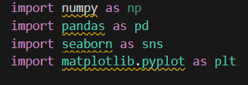

import numpy as np
- Library: NumPy
- Purpose: Provides support for numerical operations

import pandas as pd
- Library: Pandas
- Purpose: A powerful tool for data manipulation, cleaning, and analysis.

import seaborn as sns
- Library: Seaborn
- Purpose: Built on top of Matplotlib, Seaborn is used for statistical data visualization.

import matplotlib.pyplot as plt
- Library: Matplotlib
- Purpose: The foundational library for creating plots in Python.
- pd.read_csv: Reads the contents of the CSV file.

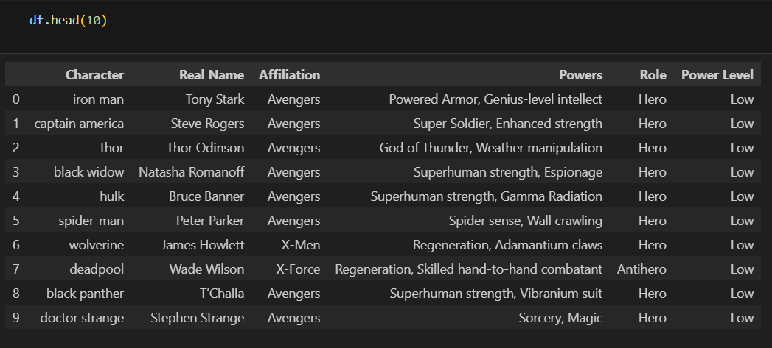
- df.head(10):Displays the first 10 rows of the DataFrame df.

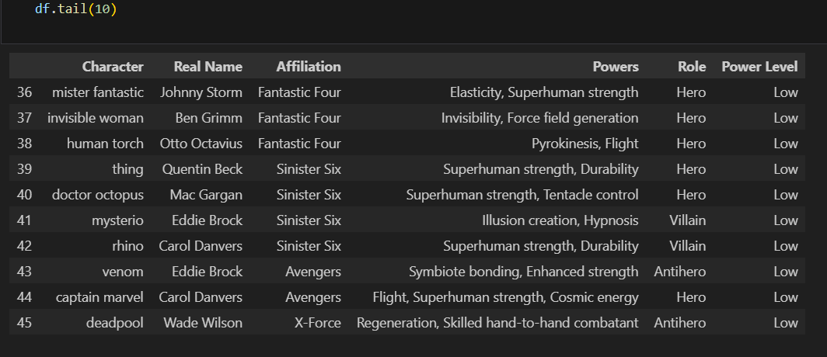
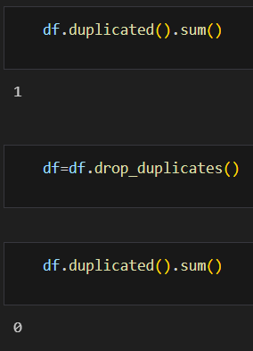
df.duplicated():indicate whether each row in the DataFrame is a duplicate of a previous row
.sum():The sum()of how many duplicated rows exist

df.drop_duplicates(): This method removes all rows that are duplicates from the DataFrame df.

df.duplicated().sum():After removing duplicates, this line checks again how many duplicate rows remain.

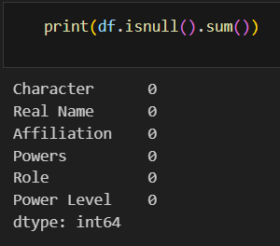
df.isnull():check for identifying missing data

- Exploratory Data Analysis
• Visualizations: Effective use of visualizations (e.g., histograms, scatter plots, box plots) to explore trends and patterns.
Insightfulness: The EDA uncovers meaningful trends and patterns in dataset.
• Depth: The analysis goes beyond surface-level observations to explore correlations, outliers, and potential relationships.
• Clarity: Visualizations are clear, well-labeled, and easy to interpret.

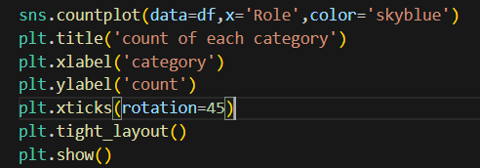
- sns.countplot: shows the counts of observations in each categorical bin using bars.
- data=df: The data source is the DataFrame df
- x='Role': Specifies the column ('Role')
- plt.title('count of each category'): Adds a title
- plt.xlabel('category'): Sets the label for the X-axis to 'category'.
- plt.ylabel('count'):Sets the label for the Y-axis to 'count'.
- plt.xticks(rotation=45):Rotates the X-axis tick labels by 45 degrees.
- plt.tight_layout():Adjusts spacing of subplots automatically to prevent clipping of labels and titles.
- plt.show(): Displays the plot.

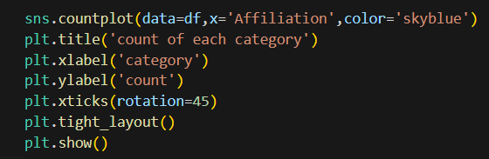

- x='Affiliation': Specifies the column
- plt.xlabel('category'):Labels the X-axis with the term "category", which refers to the different unique affiliations.
- plt.ylabel('count'):Labels the Y-axis with "count", indicating that the bar heights represent the number of times each affiliation appears in the dataset
- plt.xticks(rotation=45):Rotates the X-axis tick labels by 45 degrees.
- plt.tight_layout():Ensures that all parts of the plot are clearly visible and spaced well.

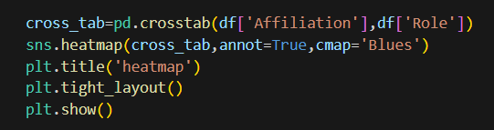
- pd.crosstab(): This is a Pandas function that computes a cross-tabulation (also known as a contingency table) between two variables.
- df['Affiliation']: Used as the rows in the resulting table.
- df['Role']: Used as the columns in the resulting table.
- sns.heatmap(): This Seaborn function creates a heatmap from a matrix-like DataFrame (cross_tab).
- cross_tab: The input matrix — our contingency table.
- annot=True: Adds numerical annotations inside each cell so you can see the actual count values.

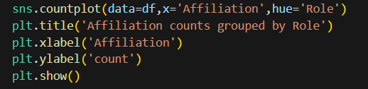

- x='Affiliation': Puts the 'Affiliation' values on the X-axis.
- hue='Role': Adds sub-categories
- plt.xlabel('Affiliation'):Sets the label for the X-axis.
- plt.ylabel('count'):Sets the label for the Y-axis

- Modeling and Prediction

- Algorithm Selection: The most suitable algorithm is chosen based on the problem type and dataset characteristics.
- Model Selection & Tuning: Appropriate models are chosen, and hyperparameters are optimized.
- Performance Evaluation: Metrics like accuracy, RMSE, or F1-score are used to assess model effectiveness.
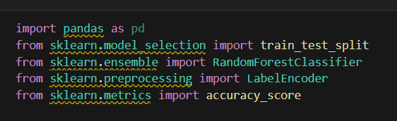
- from sklearn.model_selection import train_test_split: This function is used to split your dataset into training and testing subsets.
- from sklearn.ensemble import RandomForestClassifier: Imports the RandomForestClassifier, which is a type of ensemble learning method.
- from sklearn.preprocessing import LabelEncoder: Imports LabelEncoder, which converts categorical labels into numerical form.
- from sklearn.metrics import accuracy_score: Imports the accuracy_score function to evaluate the model.

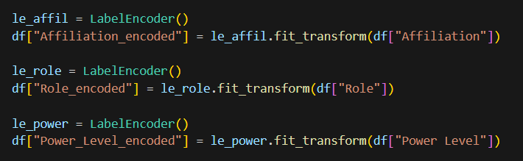
- le_affil = LabelEncoder(): creates a new label encoder instance for the "Affiliation" column.
- fit_transform(df["Affiliation"]): converting all unique categories and assigns each a unique number
- It then transforms the entire "Affiliation" column into numeric values.
- The result is stored in a new column in your DataFrame called "Affiliation_encoded"
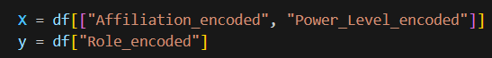
- X = df[["Affiliation_encoded", "Power_Level_encoded"]]: input data used to train the model
- y = df["Role_encoded"]:target output the model should learn to predict
train and test the data
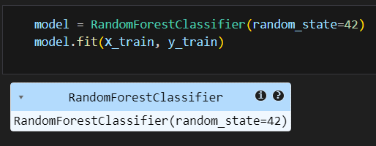
- model = RandomForestClassifier(random_state=42):Creates a random forest classifier with a fixed random state for reproducibility.
- model.fit(X_train, y_train):Trains the model on the training data (X_train for features and y_train for labels)
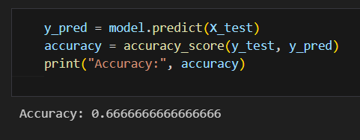
- y_pred = model.predict(X_test):Makes predictions on the test set (X_test).
- accuracy = accuracy_score(y_test, y_pred):Compares the predicted values (y_pred) with the actual values (y_test) to calculate the accuracy.

